@startumltitle Diagrama de Clasesabstract Paso {-id: Int-descripcion: String-tiempo: Int -imagen: Optional<String> +Paso(id: Int,descripcion: String, tiempo: Int,imagen: String ): Void+getId(): Int+getDescripcion(): String+getTiempo(): Int+getImagen(): String+setDescripcion(String): Void+setTiempo(Int): Void+setImage(String): Void}class PasoWextras{-utensilios: String[]-ingredientes: String[]+PasoWextras(id: Int, descripcion: String, tiempo: Int,imagen: String, utensilios: String[], ingredientes: String[]): Void+getUtensilios(): String[]+getIngredientes(): String[]+setUtensilios(String[]): Void+setIngredientes(String[]): Void}class PasoSimple{+PasoSimple(id: Int, descripcion: String,tiempo: Int,imagen: String): Void}class Receta{-nombre: String -tipo: RecipeTypes -imagen: Optional<String>-descripcion: Optional<String> -ingredientes: List<String> -utensilios: List<String> -tiempo: Int -duracion: String -pasos: List<Paso> -valor: Double -valoracion: List<Double>+Receta(nombre: String ,imagen: String,descripcion: String,tipo: RecipeTypes ): Void+addStep(descripcion: String,tiempo: Int,utensilios: String[] ,ingredientes: String[] ,imagen: String ): Void+addStep(descripcion: String ,tiempo: Int ,imagen: String ): Void+deleteStep(id: Int): Void +selectStep(id: Int): Paso+setNombre(nombre: String): Void +getNombre(): String+setTipo(tipo: RecipeTypes): Void +getTipo(): RecipeTypes+setImagen(imagen: String): Void+getImagen(): String+setDescripcion(descripcion: String): Void+getDescripcion(): String +addIngrediente(ingrediente: String): Void+deleteIngrediente(ingrediente: String): Void +getIngredientes(): List<String>+addUtensilio(utensilio: String): Void+deleteUtensilio(utensilio: String): Void+getUtensilios(): List<String> +getTiempo(): Int+setTiempo(tiempo: Int): Void+getDuracion(): String +getValor(): Double+setValor(valor: Double): Void+addValoracion(valor: Double): Void+getPasos(): List<Paso>}class RecipeTypes{+RecipeTypes: Enum}class RecetasContainer{-recetasList: <Receta>+RecetasContainer(): Void+addReceta(receta: Receta): Void +deleteReceta(receta: Receta): Void+selectReceta(id: Int): Receta+setRecetas(recetas: List<Receta>): Void+getRecetas(): List<Receta>}class User{-username: String-password: String -recetas: RecetasContainer+User(username: String ,password: String): Void+addReceta(receta: Receta): Void+deleteReceta(receta: Receta): Void+selectReceta(id: Int): Receta+getRecetas(): RecetasContainer+setUsername(username: String): Void+getUsername(): String+setPassword(password: String): Void+getPassword(): String +setRecetas(recetas RecetasContainer): Void+validatePassword(password: String): Boolean}class UsersContainer{-users: List<User> +UsersContainer(): Void+addUser(user: User): Void+deleteUser(user: User): Void+selectUser(username: String): User+getUsers(): List<User>+setUsers(users: List<User>): Void}class RecetaDAO{-sqlController:SQLController +RecetaDao(sqlController: SQLController): Void+agregarReceta(receta:Receta,userID: Int): Boolean+obtenerRecetas(): RecetasContainer+obtenerRecetasPorUsuario(userID: Int): RecetasContainer +obtenerRecetasPorTipo(tipo: RecipeTypes): RecetasContainer -mapResultSetToReceta(rs: ResultSet): Receta+eliminarReceta(recetaID: Int, userID: Int): Boolean+eliminarTodasRecetasPorUsuario(userID: Int ): Boolean }class SQLController{-connection: Connection-connected: Boolean -connectionUrl: String +SQLController(): Void+SQLController(connectionUrl: String): Void-start(connectionUrl:String): Boolean+isConnected(): Boolean +executeQuery(query: String): ResultSet+executeUpdate(String query): Int+closeConnection(): Void+getConnected(): Boolean }class UserDao{- sqlController: SQLController- recetaDAO: RecetaDao+UserDao(sqlController: SQLController): Void+agregarUsuario(user: User): Boolean+obtenerUsuarios(): UsersContainer +eliminarUsuario(username: String): Boolean+obtenerUsuario(username: String): User +obtenerUserID(username: String): Int+getRecetaDAO(): RecetaDao }class LoginServlet{#doPost(request: HttpServletRequest,response: HttpServletResponse): Void}class PerfilServlet{#doGet(request: HttpServletRequest,response: HttpServletResponse): Void}class RecetaServlet{#processRequest(request: HttpServletRequest,response: HttpServletResponse): Void#doGet(request: HttpServletRequest,response: HttpServletResponse): Void#doPost(request: HttpServletRequest,response: HttpServletResponse): Void+getServletInfo: String}class RegistroServlet{#processRequest(request: HttpServletRequest,response: HttpServletResponse): Void#doGet(request: HttpServletRequest,response: HttpServletResponse): Void#doPost(request: HttpServletRequest,response: HttpServletResponse): Void}class VisorRecetaServlet{#processRequest(request: HttpServletRequest,response: HttpServletResponse): Void}class ExplorarServlet{#processRequest(request: HttpServletRequest,response: HttpServletResponse): Void#doGet(request: HttpServletRequest,response: HttpServletResponse): Void#doPost(request: HttpServletRequest,response: HttpServletResponse): Void+getServletInfo: String}UsersContainer *-- UserUser *-- RecetasContainerRecetasContainer *-- RecetaReceta *-- PasoRecipeTypes --> RecetaPaso <|---- PasoSimplePaso <|---- PasoWextrasRecetaDAO --> SQLControllerRecetaDAO *-- RecetaRecetaDAO *-- RecetasContainerRecetaDAO --> RecipeTypesUserDao --> SQLControllerUserDao --> RecetaDAOUserDao o-- UserUserDao *-- UsersContainerUserDao --> RecetaLoginServlet --> UserDaoPerfilServlet --> UserRecetaServlet --> RecetaRecetaServlet --> UserRecetaServlet --> UserDaoRecetaServlet --> RecetaDAORegistroServlet --> UserRegistroServlet --> UserDaoExplorarServlet --> SQLControllerExplorarServlet --> UserDaoVisorRecetaServlet --> RecetaVisorRecetaServlet --> RecetasContainer@enduml

https://uml.planttext.com/plantuml/png/xLZRRXit4Fq2_WE1lgmhxGy8Xf7M2be3HkDOjljGz87MCWA1rN93Kca2j_zUtZcyhE02xbFx4cVdScRcS6QugtTI4Q5Enn4XnTH8yPQHWo17WWUAhqSYgKI8F4ibo5xXEo8vVa4z6pRuPbAe7wZS2pRl6PysUAS4cmweLumUPsujiBOzaWFLsW-pqbPal7HcLnYXbS7hFDYwWRL660EqTS1oMdonmK-S3MXreEfcw2vSKkPfcx2Cs6TcD0yM3jhUM51e9dC09ux1P0JH251gWGhhln3QQnQbfUvN-bNpA3M19qKdoKR6POZws--QgkaWwC3ef2YKEvwySwGBj_ZAs48vNMlSYhh6xQYGsyVebrZIULdoW7Ekb9bV1IiBtz8W8sx7ZlD8NpmJxkay4MYvRQe8ztHF5T6dCl7Ziw2nlKmd6mYjPpDz-3PJUQQVYs6esxqutbic5L32iobK-JmD9psAe5GjcZKfmSqGP9o-a96B3TxoqxEUQl_i7QsXqrnfJbtzNL5zmTeQjMYk2Oe7J8PXf-ZSjTr0bxQwKaTlTcMPrQl2OHXl6M6W8rNKWlZMyYfikdMaUrNe3DMsaN-np1K49kT3jCXtp8CchwiOpFoioKMcJwjcwjgD_Qgbrk09-ZSNABOqWx7jm2bLA8xFrrdZvZA1Ss13nuNInQPP2FiQosgpvNFNk2tIwWSTbT7cXpFZJCkVpFGPePiwY-HasPp2RdwA0xjWes5D1wRCxUXdQotqp8iTyl2qmU-dqx7SV_AQJugmYGgz2OKJ6TWDldG6QLKaqmvcxFU8yzrus7J0xc3E6OKvypPfqfp0ikOpy01Xw_aC8JV1y28tIMK_IblgIV-Po35sf5sdyWyk1h1XOxII0Cs9mUbA5BmkKLxBr9iGbTTV9MqlPvznbNes7y4eNoHtlhPkiSW3C8ApK9zWbLt4q6tF1gBekMW_SZvICkMdchMoAI-qYL7Q5y_SAklYU9mRYrNkbGMjEuzcArmuqyXdQacRJZmCsLMf1lXoLhS_VD2LoS-ZAK7mSTJvx3xUfYSSHdLBU9VRuSmmLQvNxu68lElSqzhaTRCDFHOeN_5dlJsfEDjekSqT5u_oH8HPonbcwOWRdelNPUtS7ybyJ-LfL3kziNaeoiwlbu9XeICxigcetUUcNvhRnGUd1puGUROydDnmEiZi5FHXxlaqwGwor_5r_7-Kqm600ED7CQRfGgiCDRLrBcvw1zlUVX0MDjMuhPYy3ebriBuL_Kht-ihzUABYM_VP_0iYHFQZtUDi9jo__MDh7oxR_SWbJLHqSBUqWsTBG7U-fXMVQtwj5c6UGZjeDxyV_kdemAEFsw4S5czafoLVGZZr54GgDia2tjBImS3GD6JBBdm7nzMI9bbJ05YzvGSsxQZueXVX2_fku7TSAZqk-jJCQyBFIirUU-zaQoIedFaaQQ5rmlfJZufFR8GHVg9l521Rdod2BFYUIkdXtY3Kc-NyTlIQi_Mgc-bJV0s6Tyf1tpY2_xTeYUK_CSd5lzuOCTpxhxDviHV_Dw5lGeIAHVXztxit9hl1p5FrNb5T-SdAwx0LsKzq-FD4try5E_jZvkMVVU_jtCzAbTZ_xePGt8yM9Bz8agvA91TMDGGy-8MF_FNJ20Gr4I1AEMJE20AL86oDWE1Yjt9lWxA573M12YZFIguSsc8JOGd9L8MAnGJnsWfxUHS3rY2nPH7TwtLWzQ721NNzNVYEJeFvNVrl

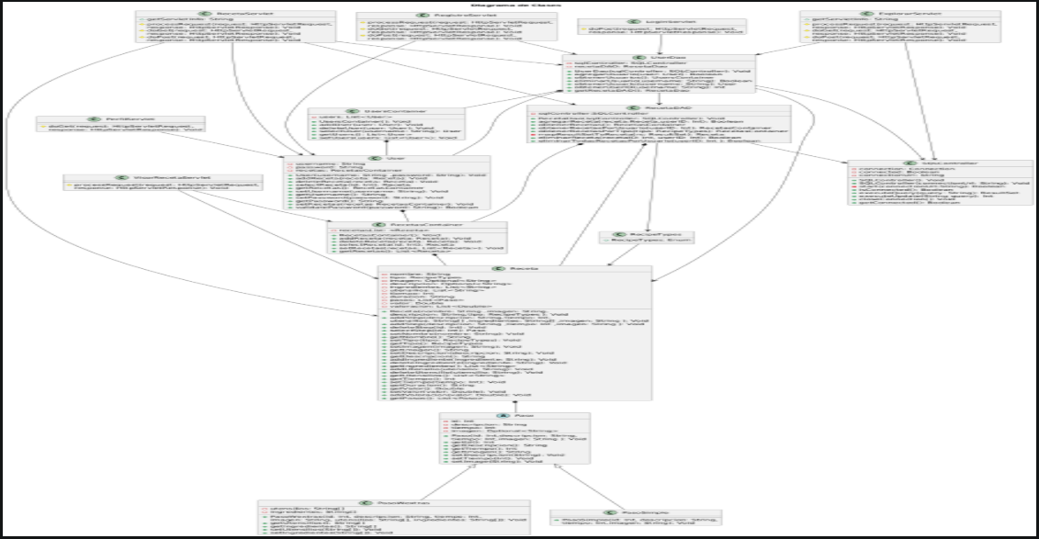

@startumltitle UML Diagrama de Paquetespackage "logic" { package "Steps" { class Paso class PasoSimple class PasoWextras } class User class UsersContainer class Receta class RecetasContainer class RecipeTypes }package "dao" { class UserDao class RecetaDAO class SQLController}package "servlet" { class LoginServlet class PerfilServlet class RecetaServlet class RegistroServlet class VisorRecetaServlet class ExplorarServlet}UsersContainer *-- UserUser *-- RecetasContainerRecetasContainer *-- RecetaReceta *-- PasoRecipeTypes --> RecetaPaso <|---- PasoSimplePaso <|---- PasoWextrasRecetaDAO --> SQLController :useUserDao --> RecetaDAO : useservlet --> dao : useservlet --> logic : use dao --> logic : use@enduml

<https://uml.planttext.com/plantuml/png/TPFTJiGW48MVW7UOxAK9Bx0nPetrhiQVkdezQSU6I0i2DMjqtrsWTAMjUqF2TuOvvJ3TMOV63Prap0ad2M1_Lq8Xi3NO8JG43_Wna2FBDDRls19if6f5lO5l1d1YbIDjHmPGIxJM7xHgiQr4foKju2iTd44RgL-EcRotP1PRUwDwXwAV2KzKayCLE5ShD3r_QKgMH_PtjGRL_1B1ia2rQbrStsUiUYo3bL5IUg-yeJ_-ASdDcvO-mBuQbJmCCcz2hlde-1zlXVMcQ-L5M6NE7RizQAaCcadndylcoS85vsFsOOcxLQ1Ba5Kb3IAAKv1b3fnVJNL1WyiVpbDT6eybdWQ4dQAFJMQXmtQmnD9hPHwXU0j1O-afekZVEU6Sni4UER0czSaWOplg6_-p_080>

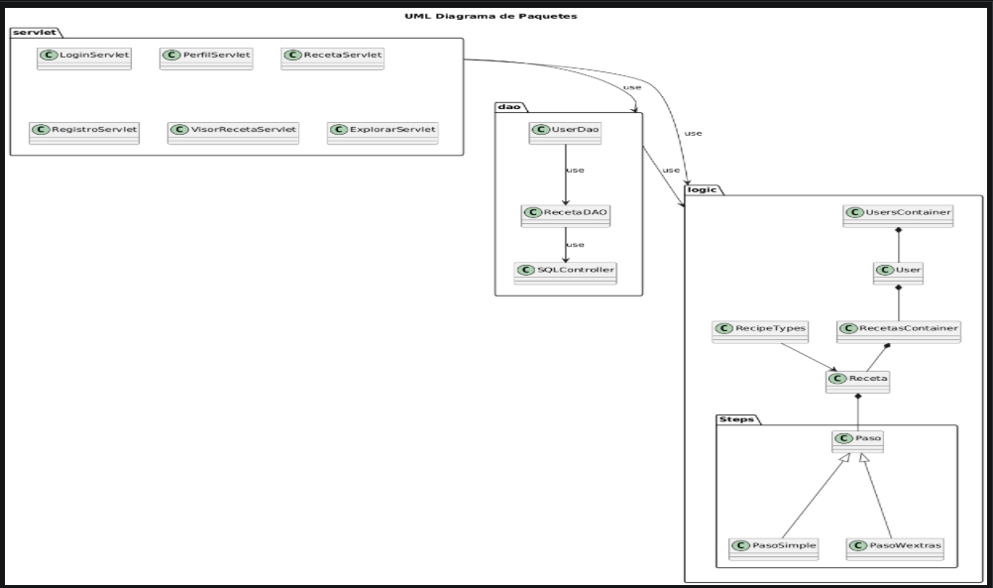

@startumltitle UML diagramas de Casos de Uso:Usuario: as USrectangle RecipeBook{(Seleccionar "Explorar Receta") as (UC1)(Espacio Recetas Almacenadas) as (UC8)(Revisar Recetas disponibles) as (UC2)(Seleccionar “Compartir tu Receta”) as (UC3)(Envio a Espacio de “Registro de Usuario”) as (UC4)(Envio a Espacio de “Inicio de Sesion”) as (UC5)(Registrar Usuario) as (UC6)(Iniciar Sesion) as (UC7)(ir a apartado "Agregar Nueva Receta") as (UC9)(Llena el formulario de “Agregar Receta”) as (UC10)(Subir Receta) as (UC11)(Envio Receta a Base de Datos) as (UC12)(Buscar recetas por nombre o tipo de cocina) as (UC13)(Guardar tus recetas para acceder a ellas rápidamente) as (UC14)(Mostrar Receta) as (UC15)}US --> UC1US --> UC3UC1 --> UC2UC2 --> UC8 : lleva a UC8 --> UC13 : alli puedeUC8 --> UC14UC3 --> UC4UC4 --> UC5 :si ya hay tiene un usuario asignado UC4 --> UC6UC6 --> UC5UC5 --> UC7UC7 --> UC9UC9 --> UC10UC10 --> UC11UC11 --> UC12UC12 --> UC8UC13 --> UC15UC14 -- UC15UC15 --> US@enduml

https://uml.planttext.com/plantuml/png/TLHHRjim33s1xa3aA_aeK2TfqkHZQ9CLmu1s7p5y0CRcF66oP4Xoi68Oq8Di7plBRjAJZB8b9nsmlqSzFfAFD7pdF5hVDKe8BxqYWEBf4Ig9jSK67LG4UtIc1uKpGcmBrw6LPWlC5hcmL7hKDIiFLCgMTiPy_IwcEIagIsaqMfWyV6kLiOmuXJnEPa4xBVRPJ4mVN8kS5oa7zwh1aZHMw5BQBQSTw2JTM877aQurMXuLZMdpcNZRz_NbvzuqBVkJ5dmNjQyllv9Y4Vhh4tT7I7EmJzOTg9REMpFOxWrVw9R_rNtKCWOvEPxYGdJJk-ZByconQ29NJFPQfWPbOjRCyFW868nWPM1oNrkgEV5JHoVyTwSRpdzKl40W1P-DRJeL6iNvalHY5UaMropCkwDCv9d9Hhi3myFiq54e-HwzSUTCFi5qrxcIEzXugDPOqAOvMW83NhRz9AKffSRnCmXt-C3xg33SoPsrQBbPML95OGEa53_QFxzRMM53sjDO8LpaoGohJUD7YlV-GuWYXwkhTy3n6Iu4Xn7F6SyZleKjA1LsYo1269KBVaUb9BGTJtJ9B3bOn23WPSGti7KIdX6-u3ER9qtGQUY6s_E0ijRXeXUA5UDLKejGOS1hnkk8DumtgVLrC76TeYn4oLCMJ6MZAz5RY5IedOMcOn0xvKBSaQxuZ_0N

